**Pushing or pulling loads using wheeled equipment**

|  |  |  |  |
| --- | --- | --- | --- |
| Assessors Name: |  | Date: |  |
| Company Name: |  | Location: |  |
| Detailed Description: | | | |

***Are there indications that the operation is high risk? (place an x in the appropriate box)***

|  |  |
| --- | --- |
|  | The operation has a history of incidents (e.g. company accident book records, RIDDOR reports) |
|  | The operation is known to be hard or high risk work. |
|  | Employees doing the work show signs that they are finding it hard (e.g. breathing heavily, red-faced, sweating). |
|  | Discussions with employees doing the operation indicate that some aspects are difficult. |
|  | Other indications, if so what? |

***Identify the type of equipment and insert the colour band and numerical score for each of the risk factors in the boxes below***



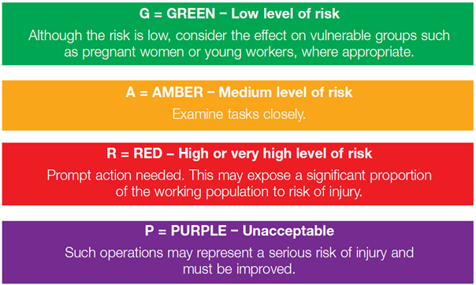

**Numeric Score to Colour ratio:-**

